Department of Computer Science and Engineering (Data Science)
CSDS-A | Batch A9 (CSE - Data Science, Section A)
Privacy-Preserving Machine Unlearning in Federated LLMs: A Certified Right-to-Be-Forgotten Framework
(ForgetSafe)
S.No. | Student name | Roll / hall ticket no.
1 | G.SHASHANK | 23K91A6761
2 | B.SATHISH | 23K91A6719
3 | G.RAKESH | 23K91A6759
4 | B.AKHIL | 23K91A6721
Under the guidance of: [GUIDE NAME], [DESIGNATION]
SCOPE AND LIMITATIONS
This document states what ForgetSafe covers and what it deliberately does not, the assumptions behind the design, and the honest limitations of the system and of the evidence for it.

1 Scope of the Project
In scope. The project delivers the following, all present in 8.ProjectCode and exercised by the tests and the measurement scripts:
- A federated training procedure over five simulated clients (Finance, Healthcare, Education, Retail, Travel), each holding five text records, with per-client L2 clipping and Gaussian noise on the aggregate (certified_unlearning/engine.py, model.py, dataset.py).
- Client-level unlearning by subtraction of the tracked clipped update, with renormalisation over the retained clients and a status of CERTIFIED or REVIEW_REQUIRED.
- A verification stack: reference recomputation, loss-based membership-inference AUC before and after, public-set perplexity and next-character accuracy, and a utility-retention percentage; and a hash-chained, append-only audit ledger with an on-demand verifier and a downloadable JSON certificate.
- A localhost JSON API (nine routes), a React web interface with a landing page and five screens, the original single-page interface, a Tkinter desktop interface and a command-line demonstration.
- Measurement on synthetic data at three scales: the product's 25-sentence corpus, a generated corpus of up to 4,000 clients, and a neural study in which 8 clients fine-tune low-rank adapters of a 137,151-parameter recurrent network (scripts/run_*.py).
- Testing: 5 unit tests, 14 smoke checks, a load and concurrency test, 58 security probes and 20 scripted synthetic-user acceptance journeys.
Out of scope. The report does not claim:
- Pre-trained billion-parameter LLMs, GPU training and federated-learning libraries; the neural study stays on a CPU workstation.
- Sample-level or class-level unlearning (only whole-client removal is implemented) and multi-round federated averaging (one aggregation round).
- A privacy accountant for repeated releases, secure aggregation, authenticated or encrypted storage of the tracked updates, and signed audit records.
- User authentication, authorisation and multi-tenant operation; the interface has no login.
- Any legal determination of compliance. The software demonstrates a mechanism; it is not a compliance product.

2 System Boundary
The two diagrams below show the boundary of ForgetSafe: what flows across it (context diagram) and who may do what inside it (use-case diagram).
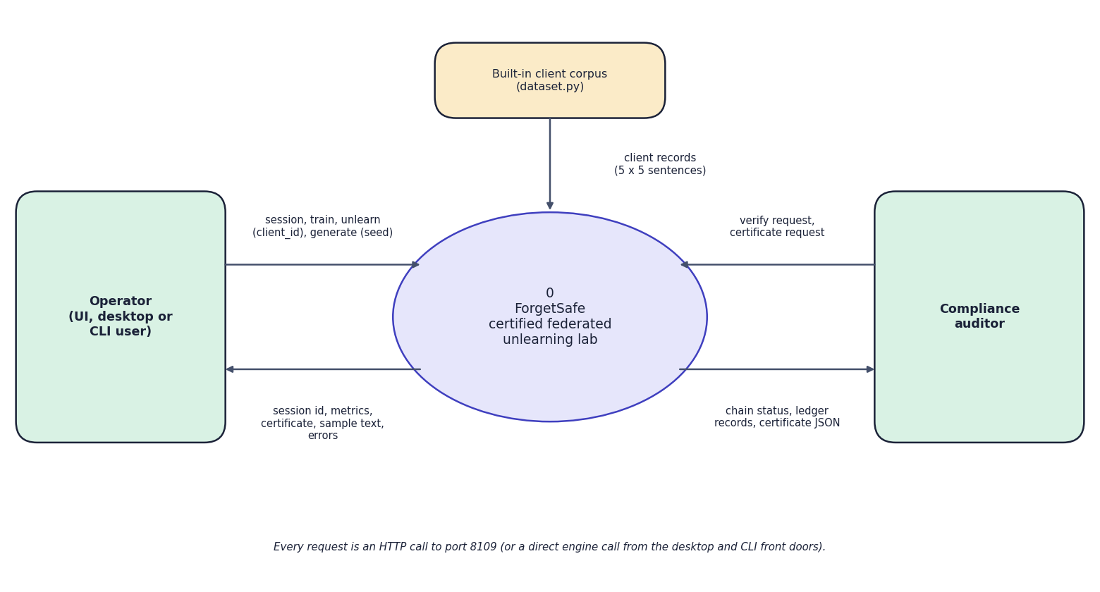
Fig. 1: Data-flow diagram, level 0 (context)
At the highest level ForgetSafe is one process, drawn as the circle labelled 0, with three external entities. The operator (a person using the web interface, the desktop window or the command-line demonstration) sends session and train requests, the client id to remove and a seed text, and receives the session id, the metrics (epsilon, perplexity, accuracy), the certificate as JSON, sample text and error messages. The compliance auditor sends verification and certificate requests and receives the chain status, the ledger records and the certificate JSON. The built-in client corpus in dataset.py (25 sentences) is the only data source and flows into the system. The note at the bottom states that every request is an HTTP call to port 8109 or a direct engine call from the desktop and command-line front doors; there is no database server, model hub or message queue.
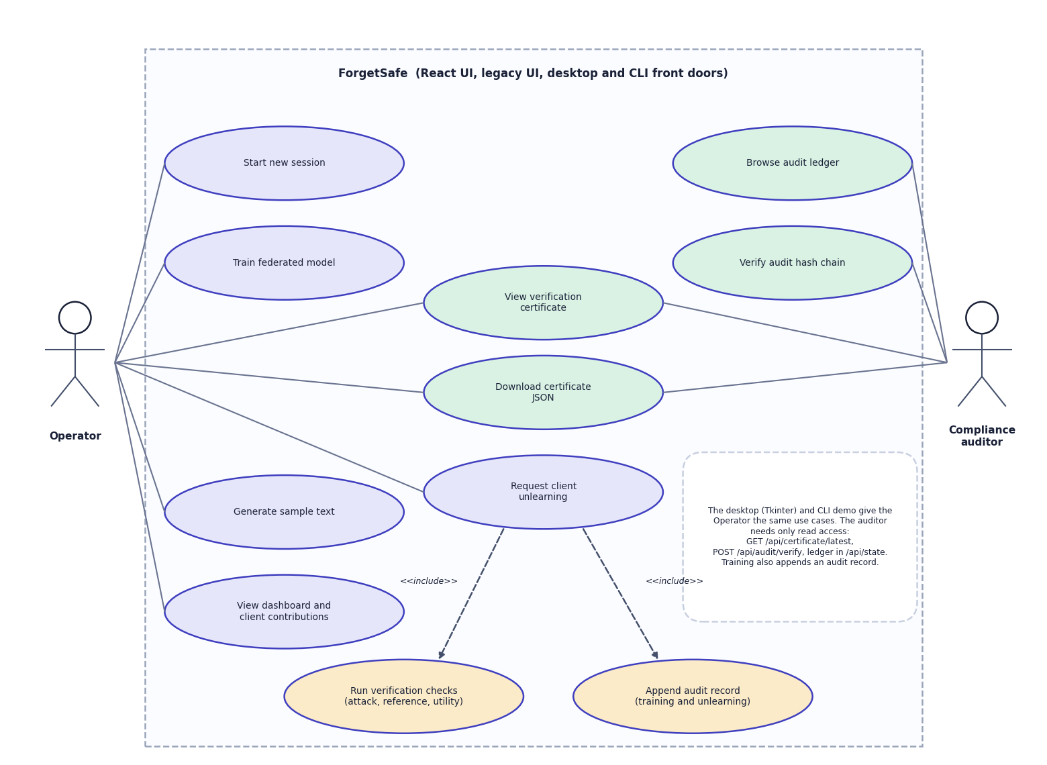
Fig. 2: Use-case diagram
Two actors use the system, which the frame labels as the React UI, the legacy UI and the desktop and command-line front doors. The operator starts a new session, trains the federated model, generates sample text, views the dashboard and the client contributions, and requests the unlearning of a client. That last use case includes two others, drawn with dashed include arrows: running the verification checks (attack, reference, utility) and appending an audit record for both training and unlearning events. The compliance auditor browses the audit ledger and verifies the hash chain. Viewing a verification certificate and downloading it as JSON are shared by both actors. A note on the diagram records that the desktop and command-line interfaces expose the same use cases to the operator and that the auditor needs only read access (GET /api/certificate/latest, POST /api/audit/verify, the ledger in /api/state). The diagram contains no login or role use case because the application has no authentication; that absence is recorded as a limitation of the system.

3 Boundaries and Assumptions
The boundaries of the work are stated once here, each with the evidence that fixes it; Chapters 7 and 8 give the measurements and the scope-and-limitations document repeats them.
- Scale. The product's model is a character-bigram model with 1,089 parameters; the neural study uses a frozen 137,151-parameter GRU with 8 synthetic clients and one aggregation round, on one CPU workstation. Exact subtraction relies on an aggregate that is a sum of stored updates; multi-round, non-linear LLM training would not have that property.
- Data. All data are synthetic: the product's 25 hand-written sentences (membership AUC resolves 0.04), a seeded-grammar corpus of 200 training and 200 held-out sentences per client, and the neural study's template language. No real-world corpus is used, and no result is presented as one.
- Noise at the default setting. With noise multiplier 3 the model reaches perplexity 130 on the baseline seed (142 +/- 28 over 50 seeds) and about 4 % next-character accuracy; the membership attack is at chance before unlearning (AUC 0.52 +/- 0.22). Larger federations dilute the noise (useful from 1,000 clients at epsilon below 1).
- Epsilon range, noise reuse, accounting. The reported epsilon of 1.61 follows the classical Gaussian-mechanism formula, valid only for epsilon below 1 (noise multiplier above 4.84). The same noise vector is kept after unlearning and the certificate repeats the training-time epsilon; there is no privacy accountant.
- Certificate and ledger. The reference model is rebuilt from the same stored updates and noise, so a distance near 1e-14 is expected by construction; the fresh-noise comparison supplies the independent evidence. The ledger is tamper-evident, not tamper-proof: it carries no signature or external anchor.
- Service. One shared engine and no authentication; the security probes (8 defects, 15 noteworthy behaviours) rank the repairs in Chapter 10. Acceptance was exercised by scripted synthetic users, not by human participants.
The assumptions are equally explicit: the coordinator is trusted to store the clipped updates and the noise honestly; clients are honest-but-curious rather than malicious; the aggregate is a one-shot sum rather than a multi-round average; and the evaluation texts are fixed and public.
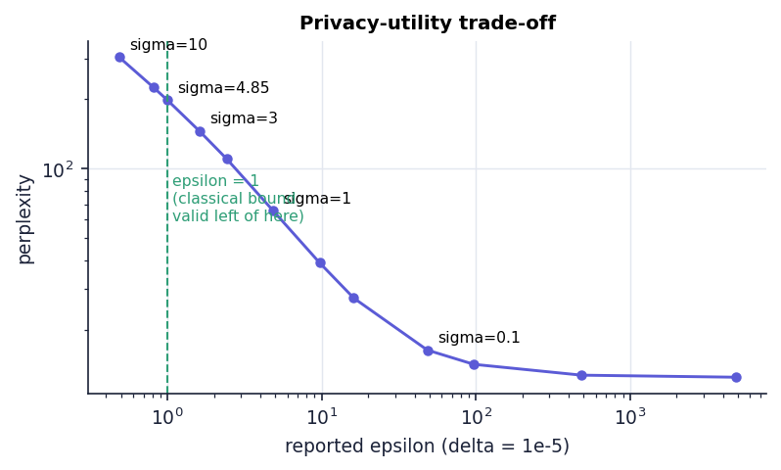
Fig. 3: Reported epsilon against perplexity across noise multipliers (20 seeds per point); the default sigma = 3 and the epsilon = 1 boundary are marked

4 Advantages and Constraints Summary
Table 1: Feasibility summary
Dimension | Verdict | Basis | Main constraint
Technical | Feasible as a demonstrator | Standard-library back end; 5 unit tests and 14 smoke checks pass; neural adapter study in 234 s on the CPU | Scale: pre-trained billion-parameter LLMs are outside the hardware
Economic | Feasible; benefit not quantified | No licences; one workstation | Production costs (compute, secure storage) not estimated
Operational | Feasible for a laboratory demonstration | Four-step workflow, confirmations, one-command start | No authentication, one shared session, model not persisted
Schedule | Feasible at this scope | Small code base and fast tests; dated phases from git | A pre-trained-LLM version would need much longer

The advantages are low cost, transparency (every number can be reproduced by the scripts in scripts/) and an architecture that separates the model from the verification and audit logic. The constraints are the scale of the models, the lack of access control and the conditions under which the evidence is informative, which are stated once in the scope document and Chapter 9.

5 Scope Boundaries of the Testing
The tests are real and repeatable; four boundaries define what their results cover.
- Scale. The unit and smoke tests run the 1,089-parameter bigram product; the synthetic-corpus study (up to 4,000 synthetic clients) and the neural adapter study (a 137,151-parameter GRU, eight synthetic clients, one aggregation round) extend the checks, but nothing here is a billion-parameter language model.
- Data. All test data are synthetic (seeded generators) or the product's own 25 sentences; the tests use fixed seeds, and the seed studies vary them.
- Acceptance. The acceptance result is from scripted synthetic users, not human participants.
- Machine. Every timing is from one CPU workstation under a quiet load, reported as medians and percentiles.

6 Boundaries of the Results
Four boundaries define what the results of this chapter cover; each is stated with the evidence that sets it.
- Scale. The product is a 1,089-parameter bigram model; the neural adapter study uses a 137,151-parameter GRU with 8 synthetic clients and one aggregation round, and the synthetic-corpus study up to 4,000 synthetic clients. No pretrained billion-parameter language model is used, and no claim is made about one.
- Data. The product's 25 sentences and every other corpus are synthetic (seeded generators); membership AUC has a resolution of 0.04 at five sentences and 5e-5 at 200, with a standard deviation of 0.22 over the 250 default requests.
- Acceptance. Interface acceptance is established by 20 scripted synthetic-user journeys, not by human participants.
- Machine and baselines. All timings are medians from one CPU workstation (i5-12500, 15.7 GB, no GPU); the only comparison algorithm is retraining. Gradient ascent, SISA sharding, pruning [2] and primal-dual methods [4] are compared with in the literature table, not implemented.

